

COMP332 HCI

Human-Computer Interaction

Project (Phase 4)

Trivago : The Desktop Website

Mohammad Mohammad: 1141648

Ibrahim Mansour: 1142988

Yousef Assaf: 1090985

**Abstract:**

The problem was on Trivago Website design, the design suffers from a fulfilled data that misleads the user and make him confused which hotel he needs and wants, which the users find that pretty annoying to keep track of .

So we experimented how to fix that, and redesigned it in a new different way and made new designs like putting a map instead which made it looks cooler and easier to keep track of things.

And we investigated what the user will like more, the old design or the new designs that has been made , And hypothetically, it goes like there is no difference with subjects satisfaction between the old design and the new designs.

And since we have one independent variable which is the design type and 3 conditions which are old design, map design and grid design.

We did an experiment and gathered the data for the within group technique and compared them using one way ANOVA.

We passed the subjects a Questionnaire separately and shuffle the order of the designs for each subject to make a more fair decisions and balance. And as a result we found out that the Null-Hypothesis was true and that there is no significant difference between the old design and the new designs according to the subjects we experimented the designs on.

**Introduction:**

Problem :

Trivago website Design (Listing Candidate hotels after searching for a location )

As shown in the screenshot below,the design suffers from fulfilled data that misleads the user and makes him confused and annoyed from the number of data that is presented for them.

Suggested Solutions:

1st Solution:

After searching for a location the user redirected immediately to a map showing location of candidate hotels in the searched and targeted area and a block view showing a deal at mouse hover.

2nd Solution:

After searching for a location the user presented a grid view of hotel deals and provides the ability for changing sorting technique and choosing the ascending and the descending order.

Null Hypothesis:

**There is no difference with subject’s satisfaction between the old design and the new designs.**

Independent Variable:

Our independent variable is the **Design Type,** we are manipulating multiple designs the current and a suggested (two) designs in order to get to the appreciated design that reaches our user satisfaction which is the dependent variable.

Conditions:

**1.Old design.**

**2.map design.**

**3.Grid design.**

Dependent Variable:

**user satisfaction is** our only dependent variable , since it responds to the change we are trying to make on the three suggested designs, the old (current ) and the two new ones, after all ,our measuring factor which directly reflects our designs is user satisfaction and the way to increase it.

**Research Methodology:**

The subjects are the 4th year female students of Commerce

College.

Using Within group Technique

We passed the subjects a Questionnaire separately and shuffle the order of the designs for each subject for more balanced participation between subjects, idea quality and group efficiency to measure subject’s satisfaction.

Questionnaire Questions:

1. How much does the design satisfies your needs?

2. How easy was the design to use?

3. How fast was the design to find what you need?

4. How visually appealing was the design?

5. How likely would you recommend the design to a friend?

Every design were Explained to each subject then asked to answer the questions.

The data were collected into an excel sheet then we applied One-way ANOVA test to measure the statistically significant differences between subjects answers to each design.

**Results:**

One-way ANOVA test Within group Technique

**A table for average and sum of the subjects answers for each questions:**

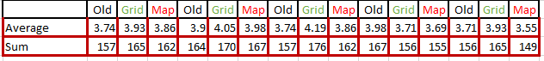

One-way ANOVA test result for each question + graph

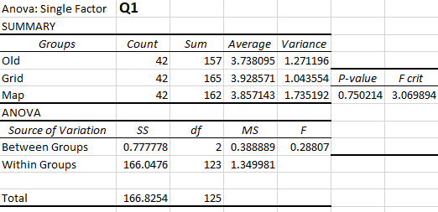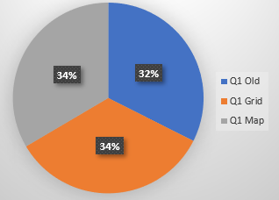

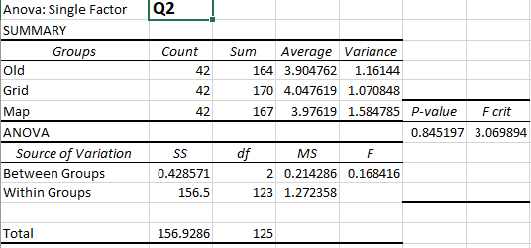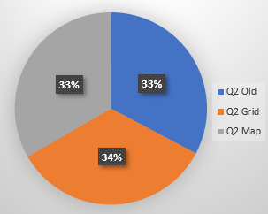

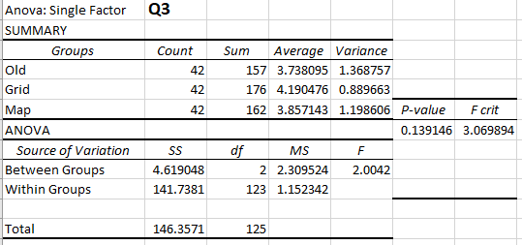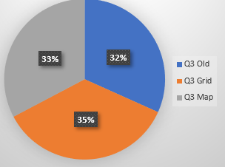

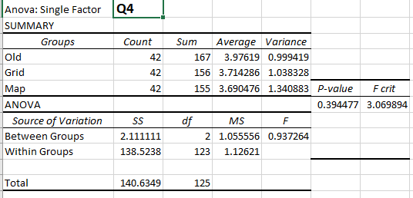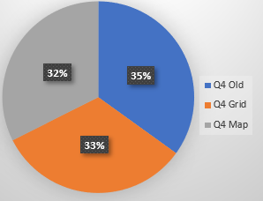

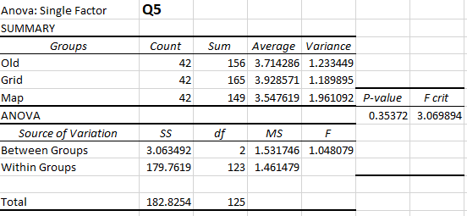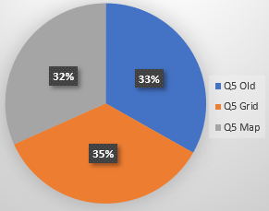

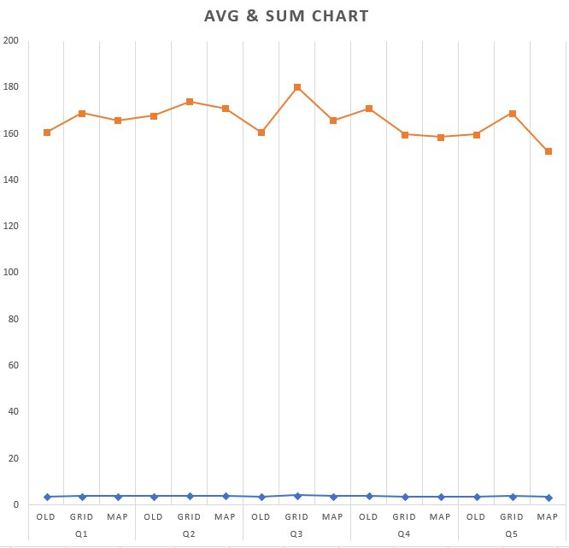 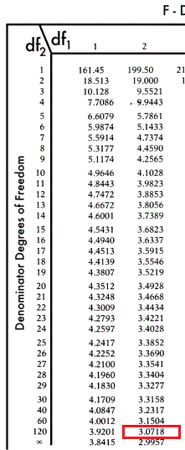

**Conclusion:**

In conclusion, after doing the population experiment on our chosen sample which is the 42 female fourth year undergraduate students, our experimental results show that the proposed null hypothesis is true; **that There is no difference with subject’s satisfaction between the old design and the new designs.** Our chosen sample was distributed between the three designs, some favored the original design, and the rest was divided between the proposed two designs.

After running the **One-Way ANOVA** test for our gathered sample data using the **Excel** data analysis tool, results showed that the calculated value was 3.06989, and by comparing it to the critical value obtained from the F-Distribution table, our value was lower than the value at 95% confidence which is 3.0718. This includes that there is no significant difference among our mentioned three conditions.